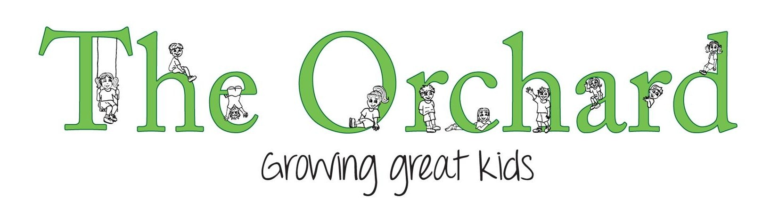

Animal Care Policy

Rationale:
The Orchard Child Care & Preschool would like to provide children the opportunity to interact and care for animals. The Orchard Child Care & Preschool recognises obligations under the Animal Welfare act 1999 with regard to animals that may be kept at the centre.

Objective:
- To encourage through example, the proper care for living things within our environment.
- To provide opportunities for children to care for animal on a daily basis.
- To educate children about the importance of responsibility when caring for and handling animals
- To ensure the welfare of animals is given the utmost priority while at the centre.
- To educate children about animal’s life cycles.

Guidelines:
- All living animals at The Orchard Child Care & Preschool will be treated with care and respect.
- Adequate shelter will be provided for all animals and it will be ensured that animals are fed when the centre is closed.
- The Orchard will not keep any caged animals (eg rabbits in a hutch).
- Children are not to go into the paddock with the pig or put hands through fencing. Pig only to be fed by adult.
- All children will wash their hands with soap and water after feeding or interacting with the animals, or returning from the paddocks.
- If The Orchard Child Care & Preschool cannot provide appropriate care and facilities, animals will not be kept.
- All teachers are responsible for cleaning up animal faeces/urine when required in the centre playground. Daily checks to be done.
- Management will ensure that animals are fed and looked after if they are at the centre when the centre is closed.
- To clean up all animal faeces staff will ensure they wear disposable gloves at all times or use tongs. Pick up faeces in a plastic rubbish bag. Dispose of in outside bin. Spray affected hard surfaced areas with bleach sanitizer.

Regulation HS16
Safe and hygienic handling practices are implemented with regard to any animals at the service. All animals are able to be restrained.

